10 The About Page

Contents

Turn on Sass 1

Create your SCSS file for the about page 1

Creating the About Page 1

Changes to the Main Section 4

Adding Another Style Class Rule for Text 8

Writing the About SASS file 10



# Turn on Sass

In Visual Studio

Remember to turn on your Watch Sass



# Create your SCSS file for the about page

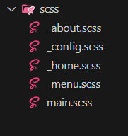

# Creating the About Page

Make sure you are inside of the dist folder, to create this file.

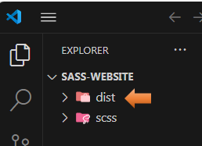

We are going to create the About file page

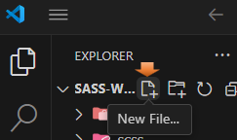

about.html

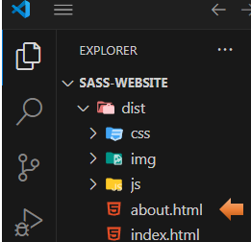

Copy and paste your index.html into your about.html page

Change the title to About Me.

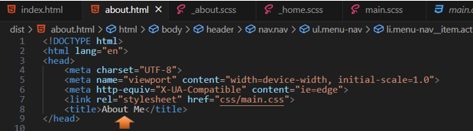

Change the Active Link to Reflect About Page

Since this is the About page, and no longer the home page, we need to remove active from home in the navigation menu, and instead put it on the about link.

*Warning, make sure that you place the word active inside of the quotation marks, and not outside of them.

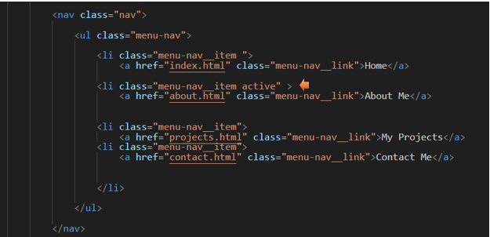

When you click on the hamburger menu, you should now see that About Me link is highlighted.



# Changes to the Main Section

Inside of the About.html, you will have a main section. You want to change the class in the main section to be about

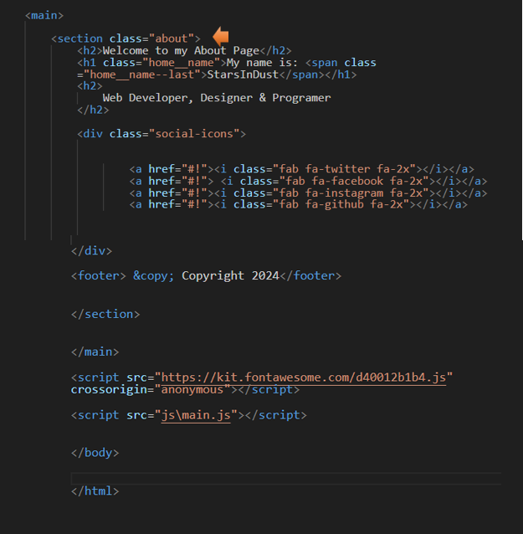

Now you want to delete all of the text that sits above the social-icons class div

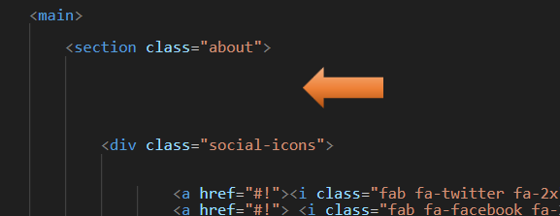

Start writing this code in here:

<div class="about__bio-image">

<div class="about__bio">

</div>

</div>

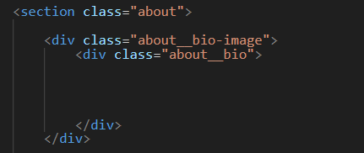

<!DOCTYPE html>

<html lang="en">

<head>

<meta charset="UTF-8">

<meta name="viewport" content="width=device-width, initial-scale=1.0">

<meta http-equiv="X-UA-Compatible" content="ie=edge">

<link rel="stylesheet" href="css/main.css">

<title>About Me</title>

</head>

<body>

<header>

<div class="menu-btn">

<span class="menu-btn__burger"></span>

</div>

<nav class="nav">

<ul class="menu-nav">

<li class="menu-nav__item">

<a href="index.html" class="menu-nav__link">

Home

</a>

</li>

<li class="menu-nav__item active">

<a href="about.html" class="menu-nav__link">

About Me

</a>

</li>

<li class="menu-nav__item">

<a href="projects.html" class="menu-nav__link">

My Projects

</a>

</li>

<li class="menu-nav__item">

<a href="contact.html" class="menu-nav__link">

Contact Me

</a>

</li>

</ul>

</nav>

</header>

<main>

<section class="about">

<div class="about__bio-image">

<div class="about__bio">

<h2 class="text-secondary">BIO</h2>

<p>Lorem ipsum dolor sit amet consectetur adipisicing elit. Quae culpa sapiente rerum dolores aliquam, fugiat eveniet commodi. Vel, nihil, numquam possimus deserunt officiis rerum in omnis error esse iusto quas.</p>

</div>

</div>

<div class="jobs">

<div class="jobs__job">

<h2 class="text-secondary">2008-2012</h2>

<h3>Bachelor Degree from International School of Technology & Design</h3>

<h6>Web Designer/Developer</h6>

<p>Lorem, ipsum dolor sit amet consectetur adipisicing elit. Repellat vero dolores eum ut, culpa ullam quis quasi exercitationem in adipisci.</p>

</div>

<div class="jobs__job">

<h2 class="text-secondary">2012 - 2017</h2>

<h3>Company</h3>

<h6>Role</h6>

<p>Lorem, ipsum dolor sit amet consectetur adipisicing elit. Repellat vero dolores eum ut, culpa ullam quis quasi exercitationem in adipisci.</p>

</div>

<div class="jobs__job">

<h2 class="text-secondary">2017 - Current</h2>

<h3>Company</h3>

<h6>Role</h6>

<p>Lorem, ipsum dolor sit amet consectetur adipisicing elit. Repellat vero dolores eum ut, culpa ullam quis quasi exercitationem in adipisci.</p>

</div>

</div>

<div class="social-icons">

<a href="#!"><i class="fab fa-twitter fa-2x"></i></a>

<a href="#!"> <i class="fab fa-facebook fa-2x"></i></a>

<a href="#!"><i class="fab fa-instagram fa-2x"></i></a>

<a href="#!"><i class="fab fa-github fa-2x"></i></a>

</div>

<footer> &copy; Copyright 2024</footer>

</section>

</main>

<script src="https://kit.fontawesome.com/d40012b1b4.js" crossorigin="anonymous"></script>

<script src="js\main.js"></script>

</body>

</html>

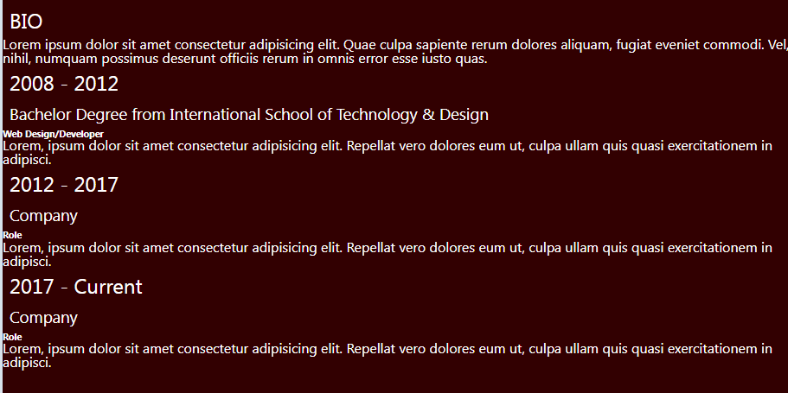

# Adding Another Style Class Rule for Text

Notice in the code that we just wrote for the about page that we have a new class for the h2 rule. This class is called text-secondary.

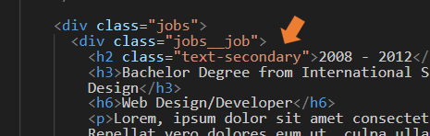

Go to the main.scss page



We can write this code right under our rule for the a tag.

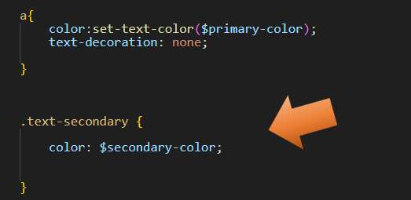

Now our Heading text takes on that secondary color, we had set up

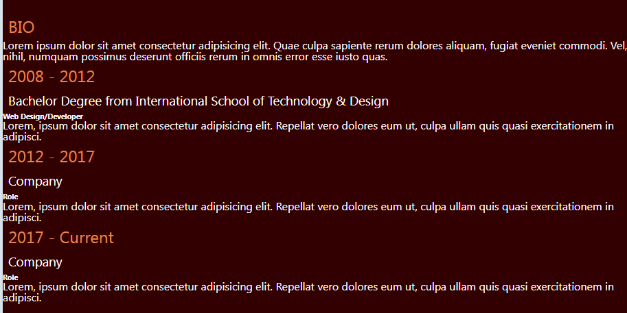

Go to the main.scss page



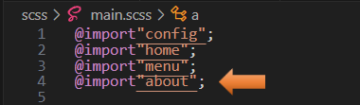

# Writing the About SASS file



This is the entire code for the about.scss file page

.about {

padding-bottom: 2rem;

&__bio-image {

height: 50vh;

width: 100%;

background:

url('../img/home-image.jpg ') ;

background-size: cover;

display: flex;

flex-direction: column;

align-items: center;

justify-content: flex-end;

p {

margin-bottom: 2rem;

}

}

&__bio {

width: 80%;

text-align: center;

.text-secondary {

padding-bottom: 1rem;

}

}

.jobs {

width: 60vw;

margin: 2rem auto 0 auto;

display: grid;

grid-template-columns: 1fr;

grid-gap: 2rem;

&__job {

background: lighten($primary-color, 10%);

padding: 0.5rem;

border-bottom: 5px solid $secondary-color;

h2, h3 {

margin: 0.5rem 0;

}

h6 {

margin: 0.3rem 0;

}

}

}

.social-icons {

display: flex;

flex-direction: column;

}

footer {

transform:

rotate(90deg)

translate(-7rem, 1rem);

}

}

Probably the most interesting part of the code above is when we come to the footer, where we turn every thing sideways. The translate of -7rem, and 1rem, is a positioning that worked well for me. You may find that you need to move these numbers around to get the copyright and the social-icons to be positioned correctly on the page for you.

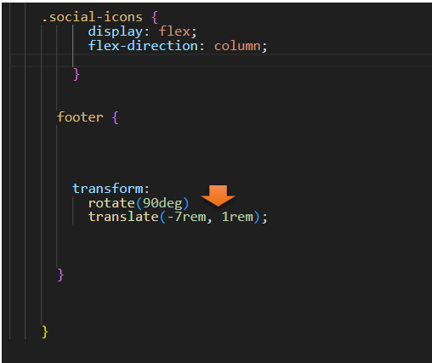

Testing the About page now, you should have this.

